**Lakhota lake**

**Lakhota Lake** is a [man made lake](https://en.wikipedia.org/wiki/Man_made_lake" \o "Man made lake) situated in center of Jamnagar, [Gujarat](https://en.wikipedia.org/wiki/Gujarat), [India](https://en.wikipedia.org/wiki/India). Lakhota Lake is popularly known as Lakhota Talav or Ranmal Lake.[]](https://en.wikipedia.org/wiki/Lakhota_Lake#cite_note-:0-2) Lakhota Fort is located on a small island in the lake. The lake is located 5 km from Jamnagar Railway Station. It is one of the largest water bodies in Jamnagar city and also among the prime places to visit in Jamnagar.

History:

In the 18th century Lakhota Fort and Lakhota Lake were both were built by King Jan Ranmal. The lake is known for being a recreational hub and a tourist spot. It is home to many rare species, including 75 different kinds of birds were found in the lake

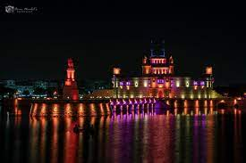

1st photo:

<https://www.google.com/search?q=lakhota+lake&tbm=isch&ved=2ahUKEwiVlK6IhafzAhWFnEsFHWmbDlEQ2-cCegQIABAA&oq=lakhota+lake&gs_lcp=CgNpbWcQAzIECAAQQzIFCAAQgAQyBQgAEIAEMgUIABCABDIGCAAQBRAeMgYIABAFEB4yBggAEAUQHjIGCAAQBRAeMgYIABAFEB4yBAgAEBg6CggjEO8DEOoCECc6BwgjEO8DECc6CAgAEIAEELEDOgsIABCABBCxAxCDAVCMywNYpYQHYNiIB2gCcAB4AIAB-QGIAfESkgEFMC43LjWYAQCgAQGqAQtnd3Mtd2l6LWltZ7ABCsABAQ&sclient=img&ei=RdtVYdXdB4W5rtoP6ba6iAU&bih=696&biw=1536&rlz=1C1CHBD_enIN932IN932#imgrc=B2V2SGk_gX6YbM&imgdii=AwcN-LHQCnm0VM>

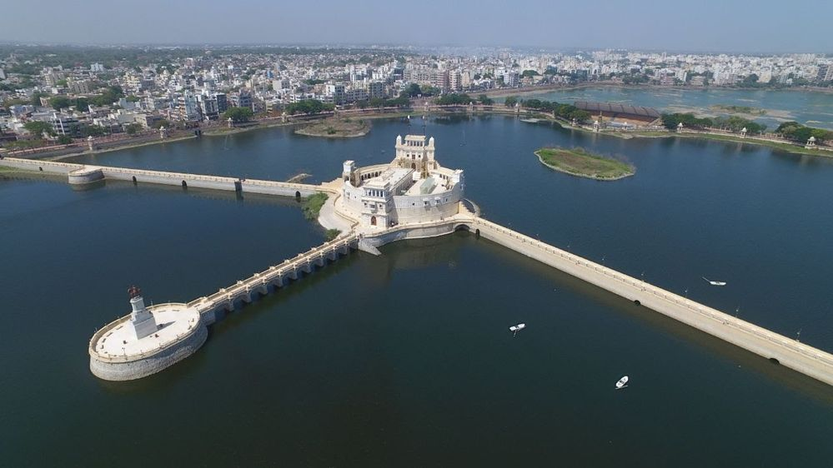

2nd photo:

<https://www.google.com/search?q=lakhota+lake&tbm=isch&ved=2ahUKEwiVlK6IhafzAhWFnEsFHWmbDlEQ2-cCegQIABAA&oq=lakhota+lake&gs_lcp=CgNpbWcQAzIECAAQQzIFCAAQgAQyBQgAEIAEMgUIABCABDIGCAAQBRAeMgYIABAFEB4yBggAEAUQHjIGCAAQBRAeMgYIABAFEB4yBAgAEBg6CggjEO8DEOoCECc6BwgjEO8DECc6CAgAEIAEELEDOgsIABCABBCxAxCDAVCMywNYpYQHYNiIB2gCcAB4AIAB-QGIAfESkgEFMC43LjWYAQCgAQGqAQtnd3Mtd2l6LWltZ7ABCsABAQ&sclient=img&ei=RdtVYdXdB4W5rtoP6ba6iAU&bih=696&biw=1536&rlz=1C1CHBD_enIN932IN932#imgrc=VW-kVWclD4yYkM>

Vlog:

<https://youtu.be/po43DAAjzjc>